# PYTHON PROJECT

PYTHON FUNCTIONS:

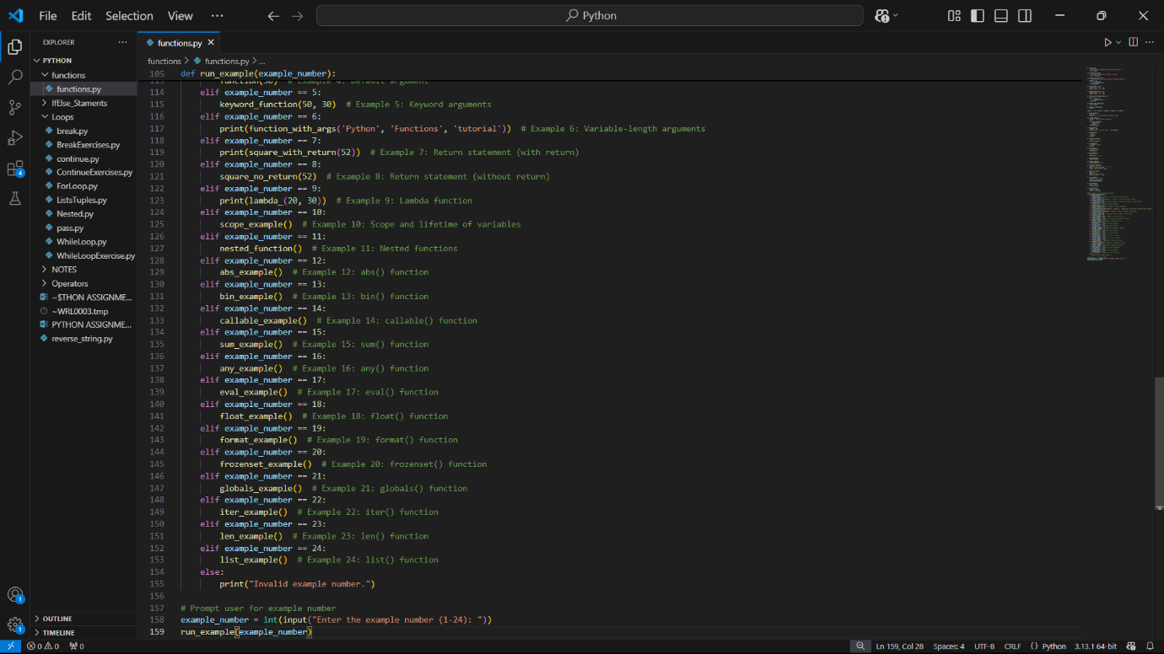

OUTPUT:

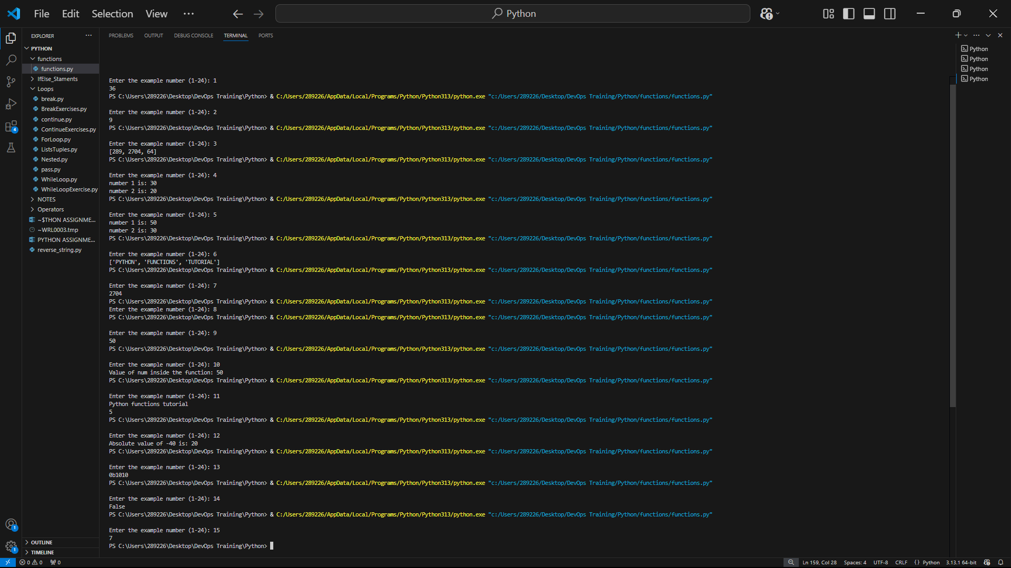

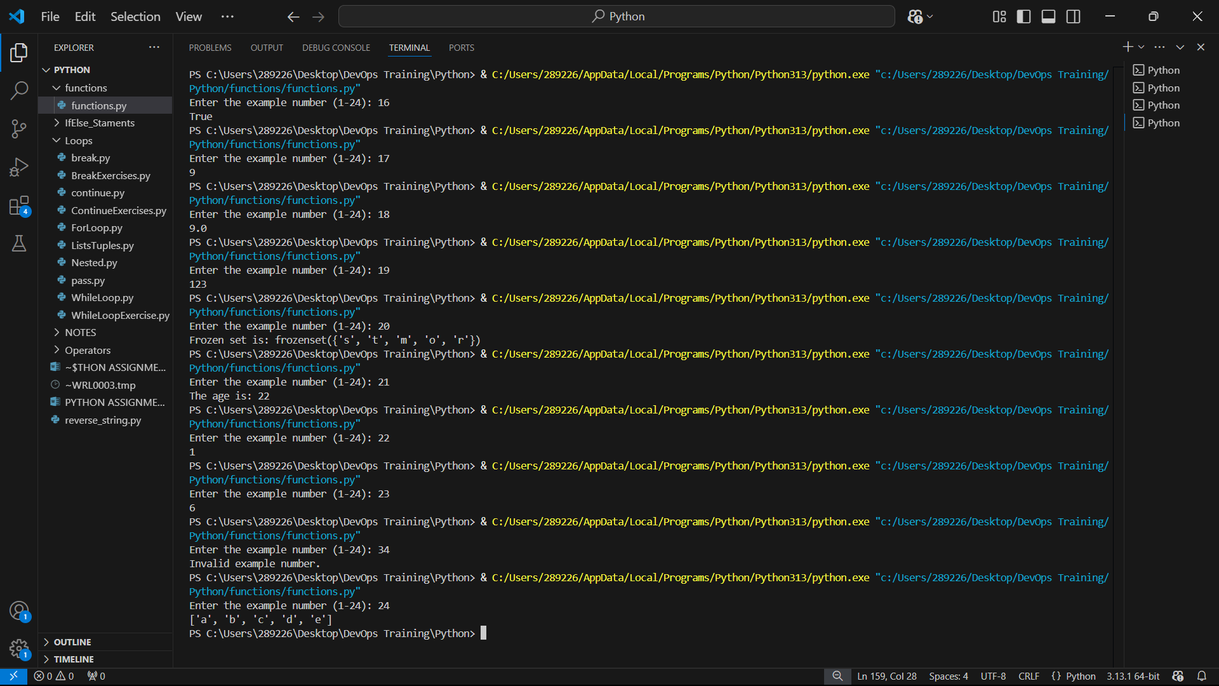

Python Modules

Python import Statement

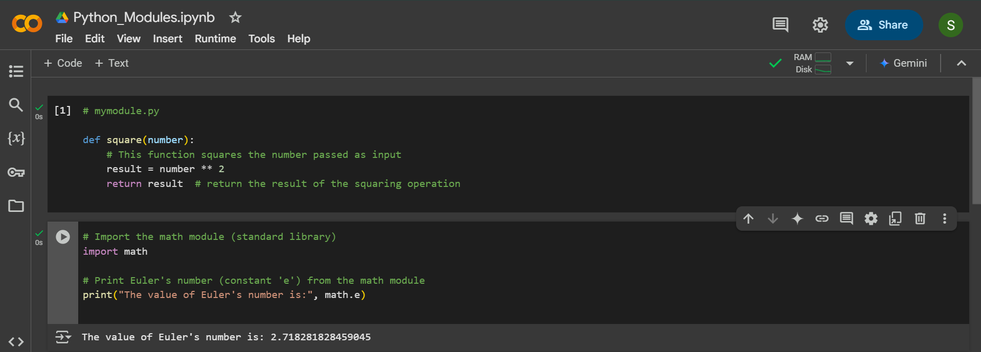

Importing and also Renaming

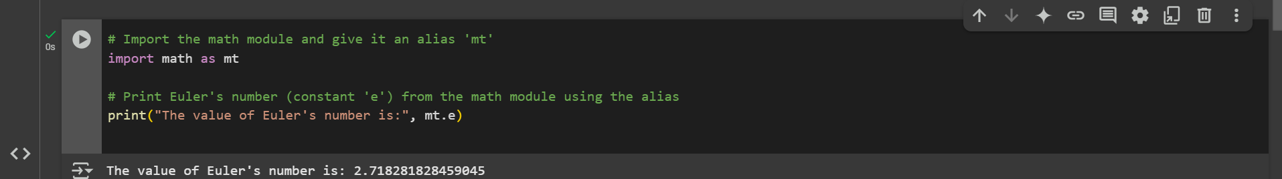

Python from...import Statement

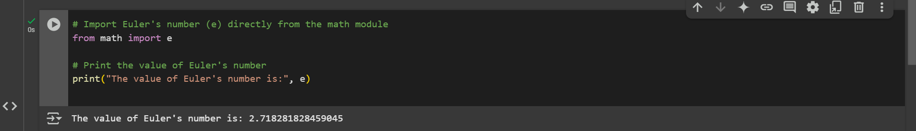

Import all Names - From import * Statement

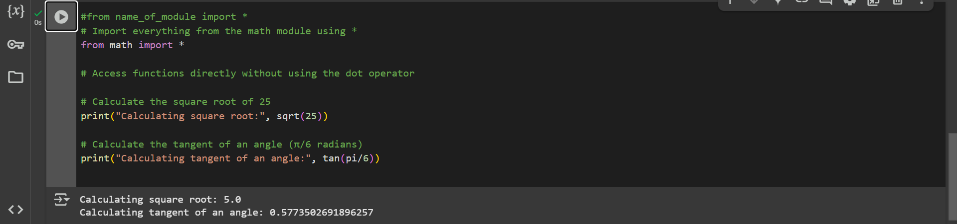

Locating Path of Modules

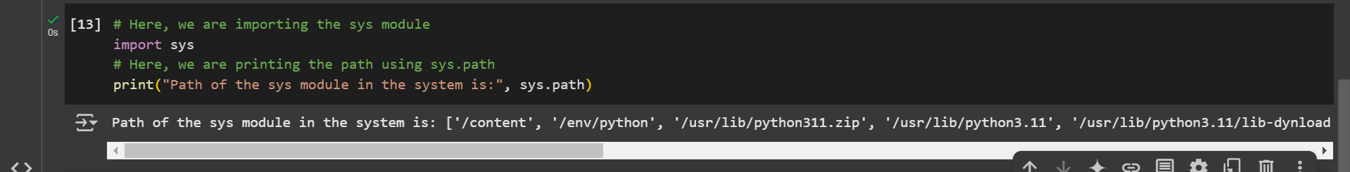

The dir() Built-in Function



Namespaces and Scoping

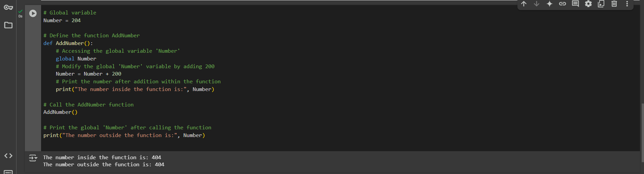

Python Exceptions

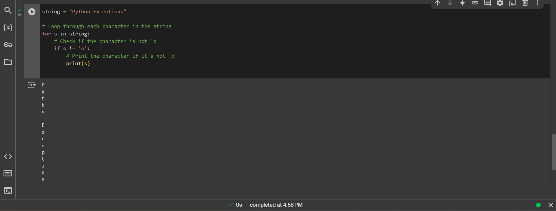

Try and Except Statement - Catching Exceptions

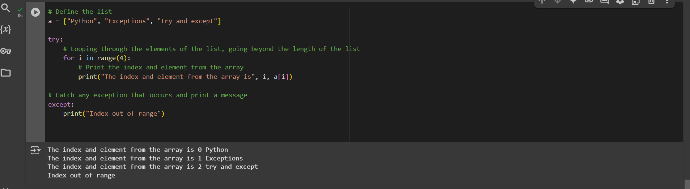

How to Raise an Exception

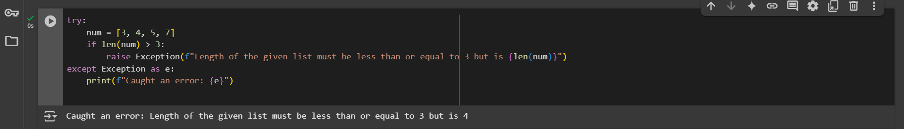

Assertions in Python

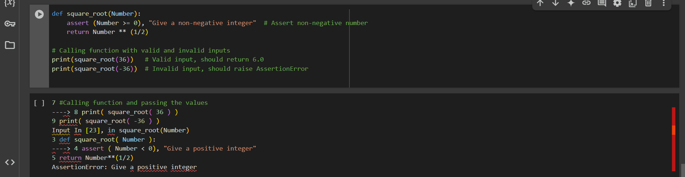

Try with Else Clause

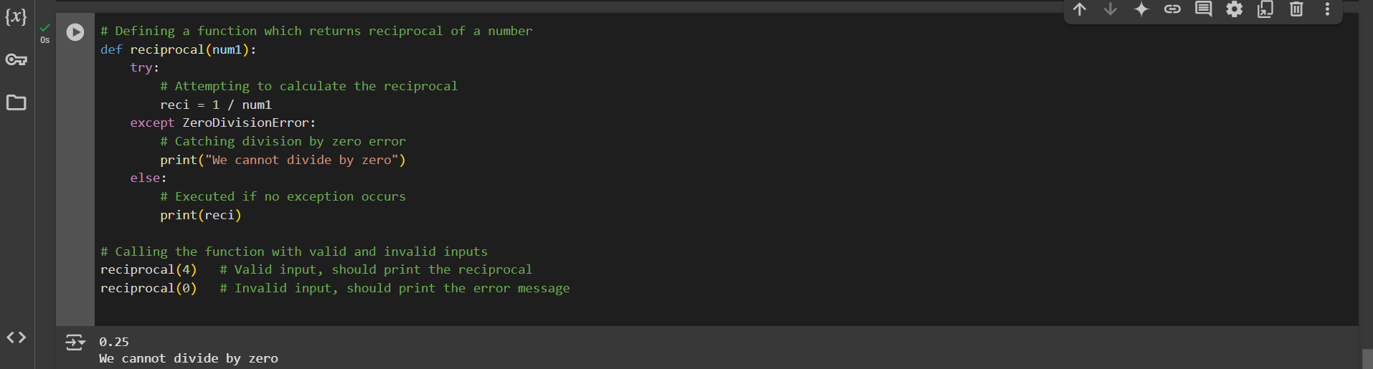

Finally Keyword in Python

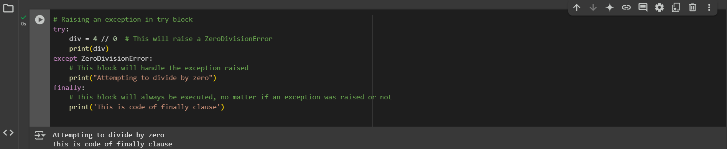

User-Defined Exceptions

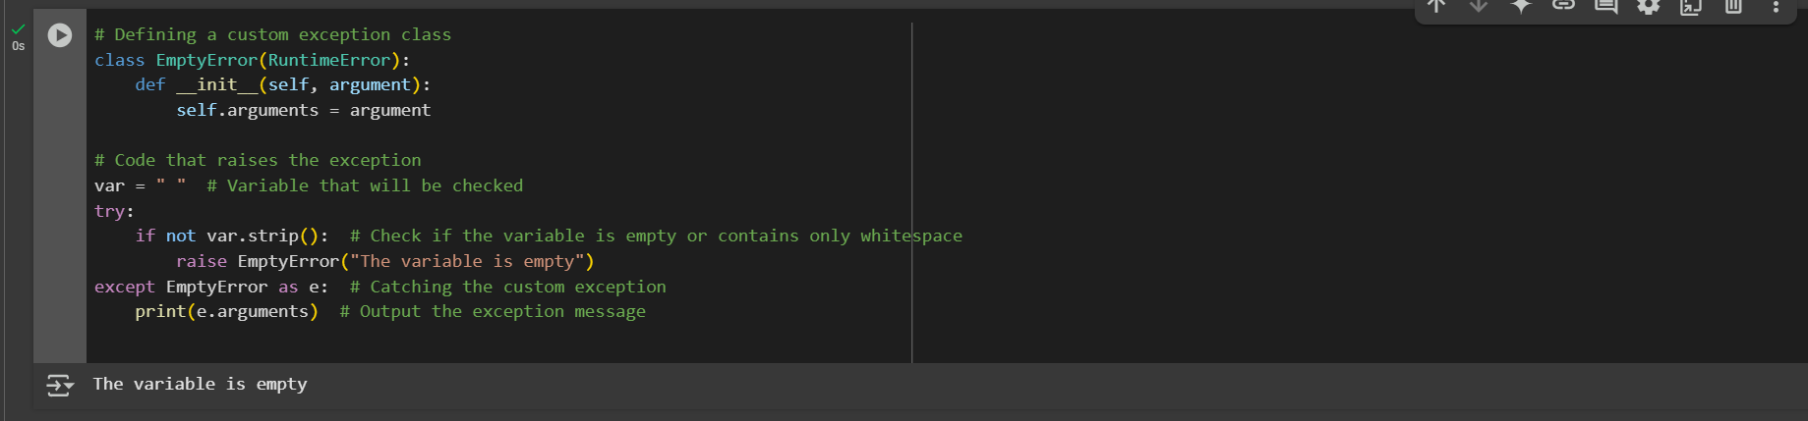

try, except, else, and finally clauses

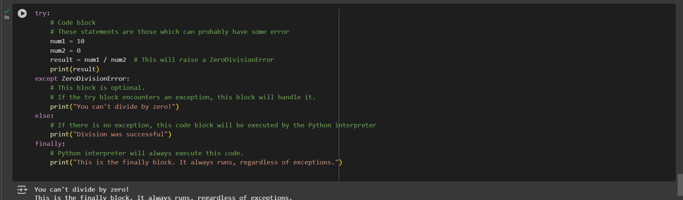

Python Arrays

Accessing array element

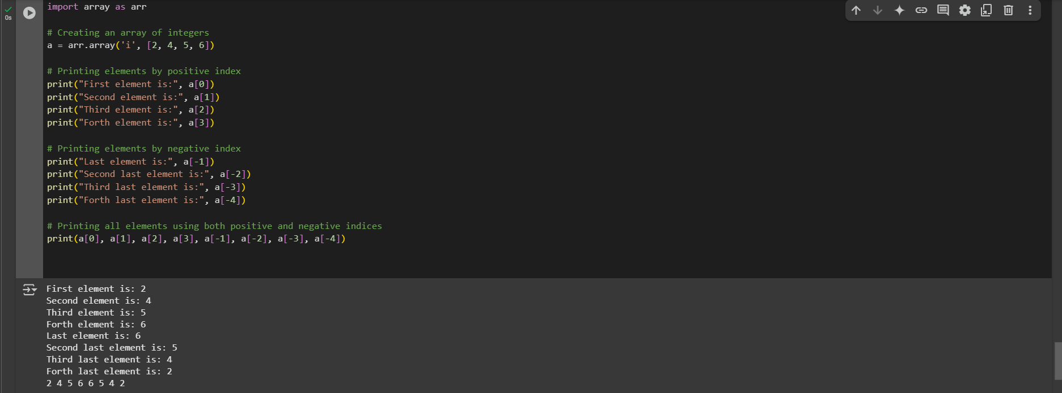

Arrays are mutable, and their elements can be changed similarly to lists.

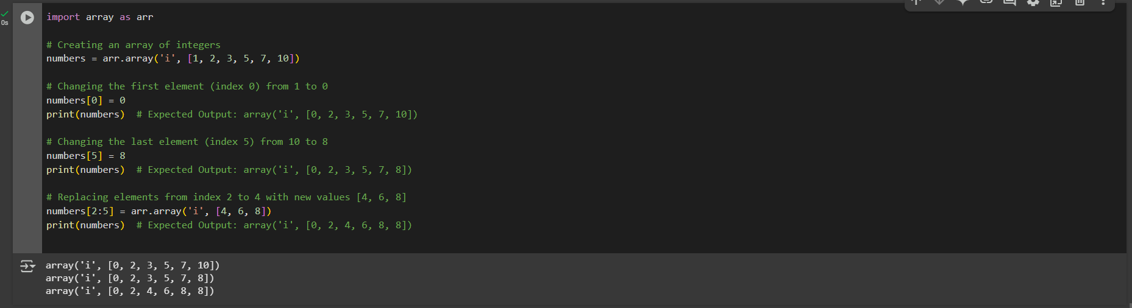

The elements can be deleted from an array using Python's del statement. If we want to delete any value from the Array, we can use the indices of a particular element.

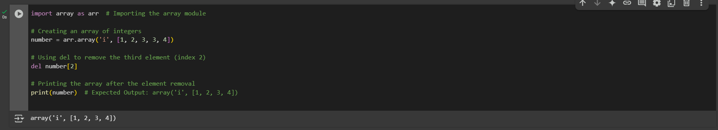

Array Concatenation

We can easily concatenate any two arrays using the + symbol.

Example 1:

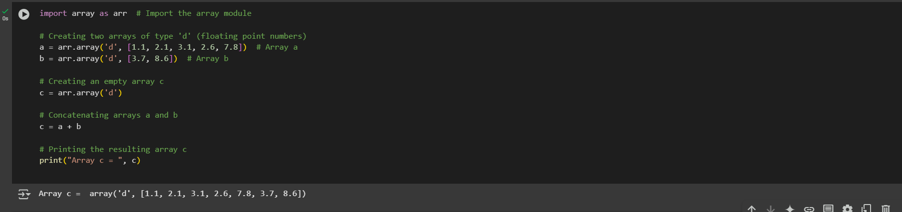

Example 2:

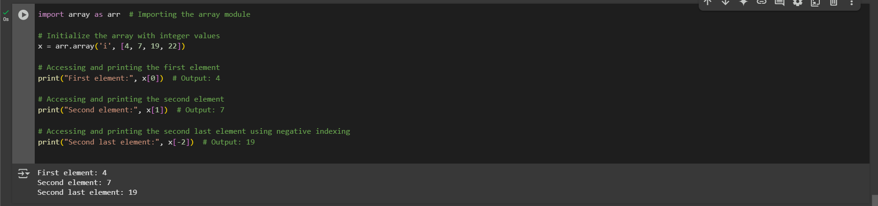

Python Decorator

Example

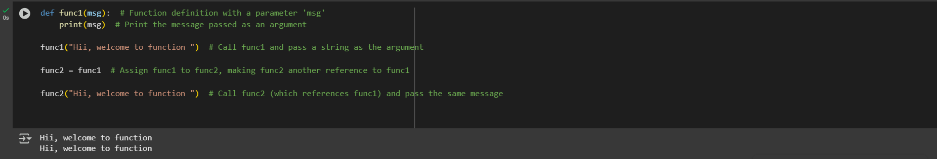

Inner Function

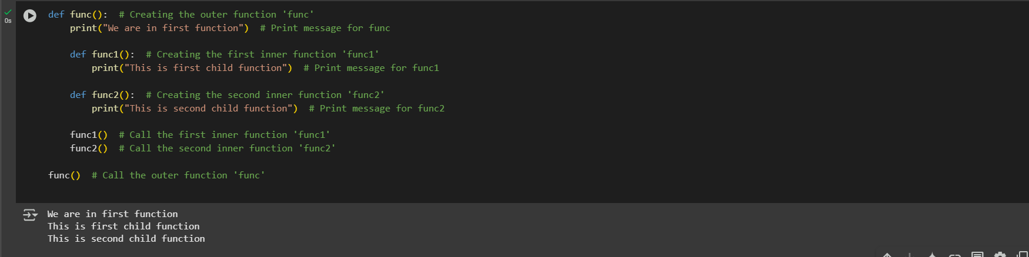

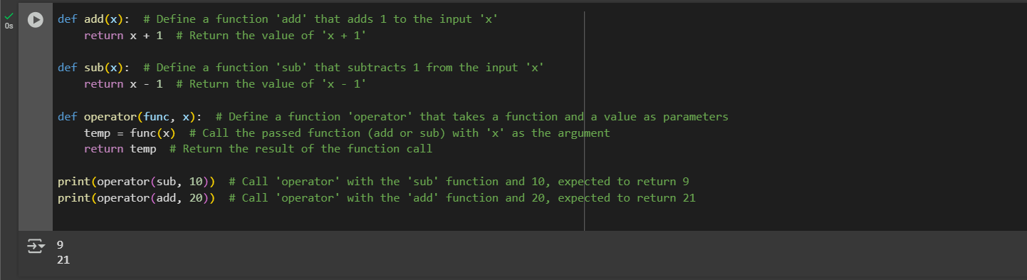

A function can return another function. Consider the below example:

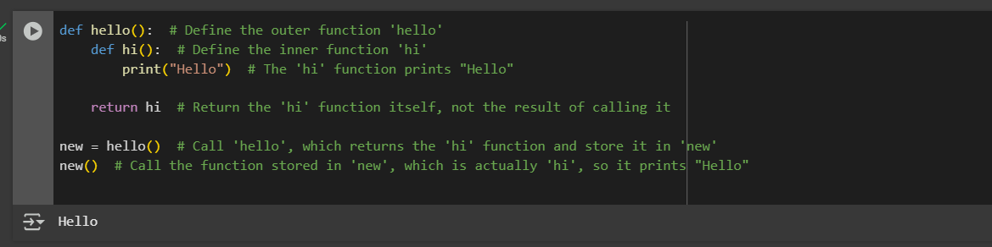

Decorating functions with parameters

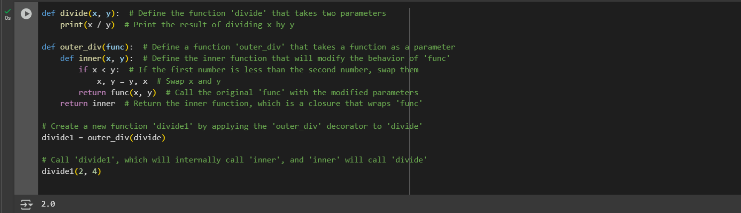

Syntactic Decorator

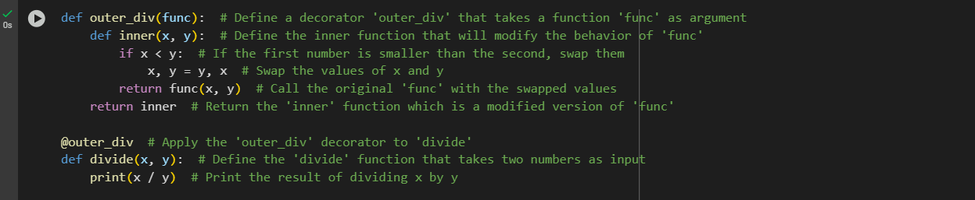

Reusing Decorator

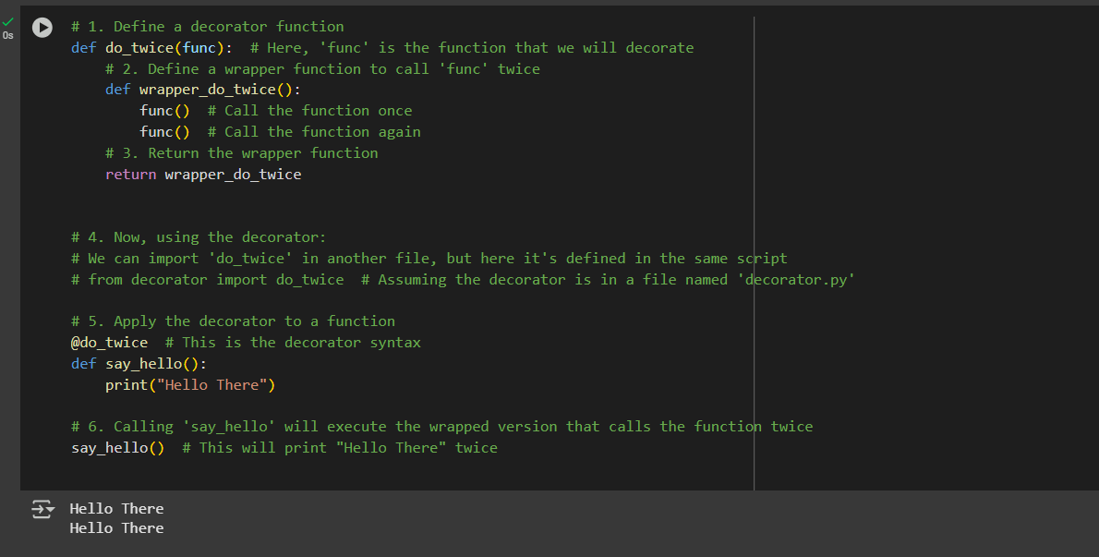

Fancy Decorators

Example: 1

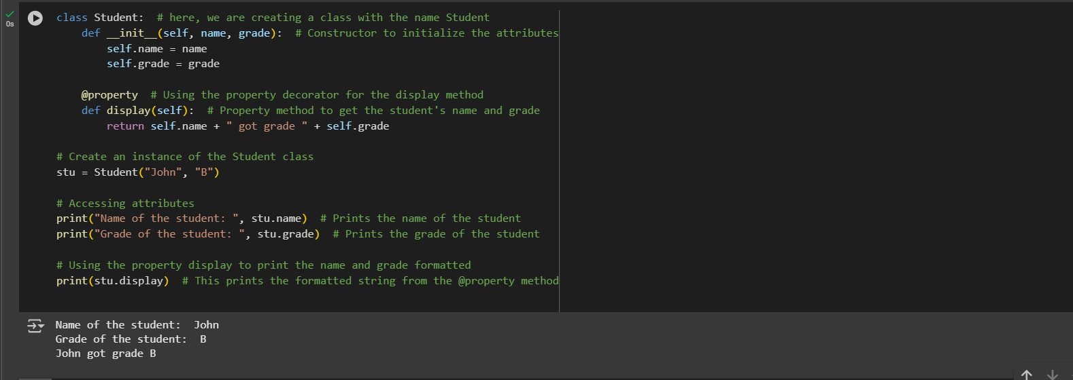

Example: 2-

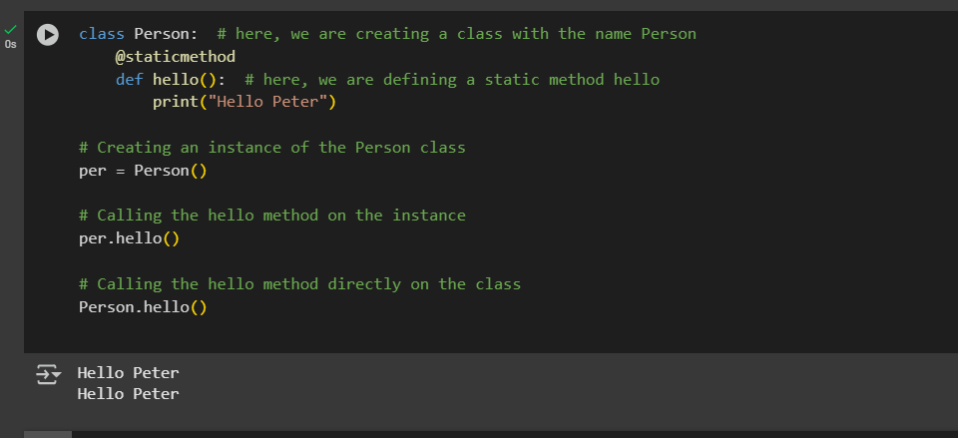

Decorator with Arguments

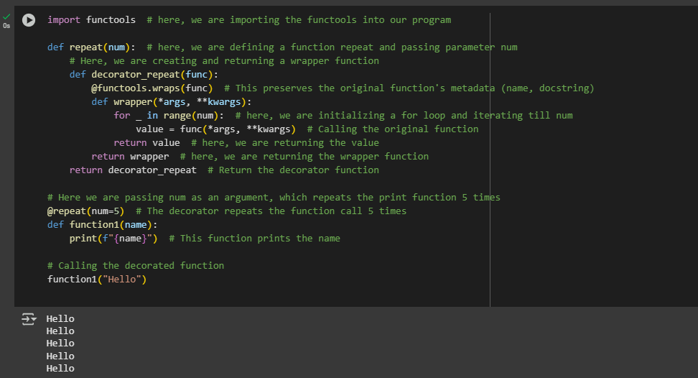

Stateful Decorators

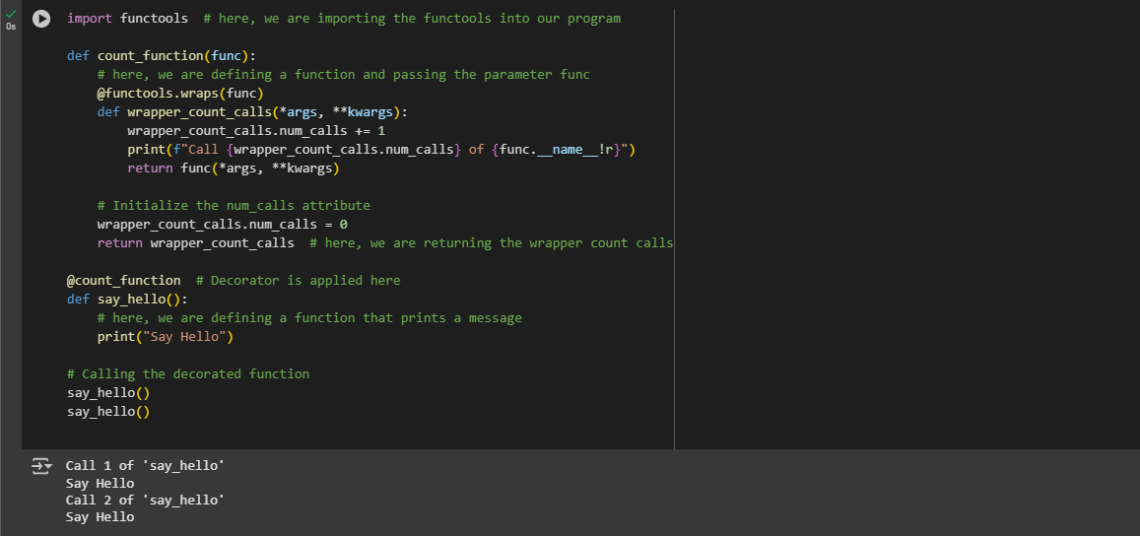

Classes as Decorators

